Sustainable vegetable system – svs model for Plant and food research

Project Proposal

Sasha Stepanov

BCIS309 – Work Integrated Learning PROJECT, software development path

Semester 2, 2023

Contents

Introduction 1

Project Details 2

Project Name 2

Overview of Industry Client 2

Project Background 2

Project Scope 4

Project Goal(s) 4

Benefits of Project 4

Project Requirements 5

Expected Deliverables 5

Stakeholder Management 6

Project Hierarchy 6

Reporting 7

Student Skills 8

General Skills Required 8

ICT Specific Skills Required 8

Skills from Relevant L6 and L7 Courses 8

Mapping of the knowledge acquired by the student and industrial deliverables 9

Approach to Learning New Skills 10

Project Plan – High Level 11

Phases 11

Detailed Project Plan 12

Timetable 14

Burndown Charts 15

Resources/Access Required 17

Risk Management 18

Approach 18

Risk Table 19

Quality Assurance 20

Approach 20

Quality Assurance Table 21

Test Plan/Scenarios/Cases 27

Methodology 29

Overview 29

Literature Review 29

Critique (Pros and Cons) 32

Professionalism 35

Professional Standards 35

Relevance of ITP Code of Ethics 36

Relevant Legislation 37

Sustainability, Inclusive Practice and Te Tiriti o Waitangi 39

Relevance of Principles to Student and Industry 39

Self-Assessments 41

Reflections 41

Approach 41

References 42

Appendices 44

Document Control

|  |  |  |  |
| --- | --- | --- | --- |
| Date | Author | Version | Status of Document/Updates Made |
| 27/07/2023 | Sasha Stepanov | v0.1 | Document Creation |
| 11/08/2023 | Sasha Stepanov | v0.2 | Submitted for feedback |
| 06/09/2023 | Sasha Stepanov | v1.0 | Signed Off |
| 06/09/2023 | Sasha Stepanov | V1.1 | Submitted for feedback |

# Executive Summary

An executive summary should summarize the key points of the report. It should restate the purpose of the report, highlight the major points of the report, and describe any results, conclusions, or recommendations from the report. It should include enough information so the reader can understand what is discussed in the full report, without having to read it.

* Brief statement of what it covers, such as a problem the business is facing or a specific proposal being made
* Concise analysis of the issue
* Necessary background information that the reader should know
* Conclusions from the author

Write the first paragraph

In your opening paragraph, state what you're presenting and why it matters to the reader. Here are some tips for doing so:

* If you're summarizing a business plan, outline the business and its purpose so readers understand the purpose of the document.
* List any challenges and how your plan might resolve those challenges.
* Consider ways to blend informative writing with engaging details to compel your audience to continue reading.

4. Outline the rest of the summary

A clear outline may help you create a summary that's succinct and easy for readers to gain information from quickly. Consider using the following categories as your outline:

* Description or summary of the company
* Challenge that the document addresses
* Solution to the problem
* Urgency section, explaining why it's important for the reader to act quickly

Structure your outline so that your main points appear in the same order that they do in the document. Mark each new section with a headline. Consider adding bullet points beneath each headline, as this structural tool lets the reader look through the information quickly.

https://www.betterup.com/blog/executive-summary-example

## Halfway Report

**Guidelines**

* **Include an executive summary of the project to date including academic and industry**

# Introduction

This document will provide all the necessary information to get familiar with the project. This includes such important aspects as the background of the company and the project or the causes of the project, scope and deliverables. It will also describe the production methodology used, risk management and the timeline of the project and all deliverables. This Project proposal will cover all these areas and prepare stakeholders for the necessary start and progression of this project to full successful completion.

This project is undertaken by a student under the close supervision of Ara Te Pukenga teachers industry and mentor.

This proposal contains the following important aspects:

* Project plan and project details
* Deliverables projects, both academic and industrial
* Student background and requirements for the project success
* The hierarchy of the project, which includes all stakeholders
* Quality assurance (academic and industrial) of the project
* Risk assessment
* Time management and timeline.
* Methodology used to carry out the project
* Professionalism, which will provide all the necessary information about the fulfillment or non-fulfillment of all necessary aspects of the professionalism of the employee and the company
* Personal reflection.

# Project Details

This section contains brief information about the project, scope, client background and current situation.

## Project Name

**Sustainable Vegetable System – SVS Model**

## Overview of Industry Client

Plant & Food Research (Māori: Rangahau Ahumāra Kai) is a New Zealand Crown Research Institute (CRI). Its purpose is to enhance the value and productivity of New Zealand's horticultural, arable, seafood and food & beverage industries. The interests of the institute are based in horticulture, arable and seafood research, specifically in the areas of sustainable production, bio protection, elite genetics & intelligent breeding, food and health science and biomaterials. The institute was formed on 1 December 2008 by merging existing CRIs HortResearch and Crop and Food Research. Plant & Food has over 900 staff based at sites throughout New Zealand as well as science and business development staff working in the United States, Europe, Asia and Australia (Plant and Food Research, 2010).

## Project Background

### Overview

New Zealand has a big problem with degraded water quality as a result of the overuse of fertiliser. To solve this problem, Plant and Food Research suggested to create a tool that would help to solve this problem.

### Current Situation

New Zealand Government has set strict water quality targets and farmers are having to reduce fertiliser to achieve these. As part of this project a model was developed that takes inputs of soil tests and other information about the crop and situation to determine exact fertiliser requirements. The model has been written as a standalone API. An external contractor developed a web interface that farmers can use to configure and receive answers from the model (SVS – N(Nitrogen)-Sight). To gain substantial uptake it is critical that the model be accessible in multiple ways so in the future alternative interfaces will be developed. It is also critical that the accuracy of the model is established and can be demonstrated at any time.

At the moment, the model and the interface do not work as they should, namely the interface is too complicated for the farmers. In addition, the results of calculating nitrogen for crops sometimes do not meet the standards, and sometimes exceed all acceptable limits.

### Future Situation

This project is aimed to provide an approach for minimising the amount of fertiliser that is applied to vegetable crops to reduce losses to the environment. A key part of achieving this is the delivery of tools to determine what is the right amount of fertiliser for specific crops at specific time and place.

For the industry, the successful completion of a project means the following:

* The possibility of obtaining new grants from both the state and private individuals.
* A sustainable product that aims to improve the environment.
* A simple and accessible interface for all farmers.
* Correct nitrogen dosages for all crops.

# Project Scope

This section will describe the main goals and objectives of the project for both the client and the student. A list of deliverables projects will also be presented from both an industry and an academic point of view.

## Project Goal(s)

### Industry

* Refactor and test a model that can be used in the future by farmers.
* Help improve N management and reduce N leaching for improved production and environmental sustainability.
* Create a working simple graphical interface for displaying the results of calculating fertilisers.
* Integrated testing using Github pull request process.
* Enlightenment of farmers in the rational and correct use of nitrogen fertilisers.

### Student

The main goal for the student is to join the team, work hard and complete the tasks with high quality and on time. Another important goal of the project is to gain experience in project management, which includes proper time management, following methodologies and successful collaboration with all project members, including industrial and academic. Finally, an important goal for the student is to gain professional experience in programming, testing and collaboration with other employees of the company.

## Benefits of Project

### Industry

The main beneficiary of the project for the industry is a tested and working model for calculating the correct amount of Nitrogen fertiliser required at a given time. The model will help farmers use less fertiliser, which will lead to a reduction in the cost of growing a crop. Also, reducing the use of nitrogen for farm purposes will reduce its release into soil and rivers, which will help improve the environment.

The end result should be a working simple interface for displaying fertiliser calculation results.

### Student

The main benefit of the project for the student is to gain indispensable experience in working in a large and real company, which will then be used to find a future job.

The project for the PFR (Plant and Food Research) company is aimed at improving the environmental situation in the country, as it aims to reduce soil and water pollution with fertilisers, which is consistent with the student's life principles.

Another important benefit from the project is personal interest, since the student will have the opportunity to use of an already existing diploma - Scientist Agronomist. The SVS project is directly related to the agricultural industry, which will positively affect the search for a future job.

## Project Requirements

Project requirements are prerequisites and features that must be enabled in order for a project to be considered complete. Project closure can only happen when customer and stakeholder needs are met. Project requirements can be business or technical requirements.

### Business requirements

* Testing the existing system for the correct calculation of fertiliser for farmers and everyone.
* Simplifying the existing GUI interface with information about the recommended fertiliser dose, which should ultimately lead to an improved user experience for the farmer.

## Expected Deliverables

Might change

### Industry

* Weekly progress report.
* WS2 (Work Stream number 2) field configurations complete and in version control
* Script to run simulations through API complete and in version control.
* WS2 Observed data formatted and in version control.
* System for visualising model performance complete and in version control
* Integrate testing with Git hub pull request process.

### Academic

* WIL document signed by all involved parties
* Weekly Progress Report
* Project Proposal and related documents such as the sensitive data non-disclosure declaration
* Halfway Report + Supervisors Assessments.
* Completed Methodology Essay
* Final Report
* PowerPoint presentation – slides.
* Poster
* Short Paper to the Poster
* Presentation to Panel
* Approval Sign off for Proposal.

## Halfway Report

Do I have to have this section here? There are no significant changes worthy of documentation.

# Stakeholder Management

Change it

This section will list all stakeholders directly related to the project. Their roles at the corresponding company and their relationships to the project will be described.

## Project Hierarchy

**Industrial party**

Name: **Hamish Brown**

Position: Research Science Team Leader/Developer - Industrial Supervisor

Address: 74 Gerald Street, Lincoln 7608, Canterbury

Contact details: Email: [hamish.brown@plantandfood.co.nz](mailto:hamish.brown@plantandfood.co.nz), Mobile: 0272261166

Name: **Irwin Taganas**

Position: Senior Desktop Engineer - Technical mentor

Contact details: Email: irwin.taganas@plantandfood.co.nz, Mobile: 021795180

Address: 74 Gerald Street, Lincoln 7608, Canterbury.

**Academic party**

Name: **Dr David Weir**

How involved in the project (Role): Course Convenor

Contact details: Email: [David.Weir@ara.ac.nz](mailto:%44%61vi%64.W%65%69%72@%61r%61%2eac%2enz), Phone: 940-8324

Address: Ara Institute of Canterbury - Madras Street, Christchurch Central City.

Name: **Dr Luofeng Xu**

How involved in the project (Role): Academic Supervisor

Contact details: Email: [Luofeng.Xu@ara.ac.nz](mailto:%4c%75o%66%65%6e%67%2e%58%75@%61%72a.ac.%6e%7a), Phone: 940-8394

Address: Ara Institute of Canterbury - Madras Street, Christchurch Central City.

**Student:**

Name: **Sasha Stepanov**

How involved in the project (Role): Bachelor of ICT student, the Developer.

Contact details: Email: [1989stepania@gmail.com](mailto:1989stepania@gmail.com), Mobile:0211842723

## Reporting

Meetings about the project with all members of the project, including the IT sector and the Scientific sector, take place at the request of the project leader Hamish Brown.

The collaboration itself with an industrial mentor takes place in person, in a messenger, emails or MS Teams. Every Monday was chosen for weekly scrum meetings. Time varies, due to the possible workload of the industrial supervisor of the project with meetings.

In addition to the formal meetings, there will be short (10 minute) face-to-face briefing meetings every Tuesday or Friday.

### Academic

BCIS309 Class Session

* Meeting Agenda: Review of the progress, receiving new instructions about academic deliverables, planning next steps.
* Time: Monday 3:00pm – 5:00pm and Thursday 1:00pm –3:00pm.
* Who is involved: All BCIS309 Students and tutors.

Weekly meeting with Academic Supervisor

* Meeting Agenda: Review of the progress, receiving new instructions, receiving feedback on the work done, planning next steps.
* Time: Monday 1:00pm – 2:00pm
* Venue: S156 or Microsoft Teams Video meeting (optional)
* Who is involved: Student, Academic Supervisor.

### Industry

Monday scrums at Plant and Food Research at Lincoln.

* Time: Monday 9:00am – 10:00am
* Attendees: Key stakeholders of SVS project or/and industrial supervisor.
* Who is involved: industrial supervisor, student.

To make the student more productive, it was decided by student and an academic mentor to work directly at the Plant and Food Research in Lincoln. This is due to the fact that the student will have the opportunity to receive assistance from an industrial mentor immediately, since his office is located in the same building. It also contributes to the development of social skills, since while working directly in the PFR, the student has the opportunity to communicate with other developers, data analysts and scientists. The third and probably the main reason why a student will work in the Plant and Food Research office is personal reasons of a family nature. It will be very difficult to work from home with a three-year-old child.

## Halfway Report

This section contains necessary updates to the project hierarchy, as well as reflections on reports and meetings during the first half of the project.

From the start of the project to the time of writing the halfway report, there were no significant changes in the hierarchical structure of the project, both industrial and academic.

### Academic

Academic reports are sent regularly every Sunday evening to allow the academic supervisor time on Monday to review them before their weekly meeting with the student.

Weekly meetings with the academic supervisor are held every Monday at 1 day as planned. There were cases when these meetings were not held in person but over the phone due to the lack of necessity. This is due to the fact that the project went according to plan and there were no critical changes or difficult situations with which the student needed help. Despite this, the entire status of the project was discussed over the phone, significant feedback was received from the academic supervisor, and further actions regarding the project were planned.

### Industry

Industrial reports are shown personally every first working day of the week.

Industrial meetings took place every morning on the first working day of the week, often Monday. It discussed the progress of the work done and planned a plan for the week, which included goals and objectives. These meetings almost always took place and take place in person in PFR.

# Student Skills

This section will provide a list of all the required skills that a student must have or should have in order for the project to be successful.

## General Skills Required

To successfully complete a project, a student must have the following general skills:

* Punctuality
* Honesty
* Kindness
* Emotional intelligence
* Creativity
* Problem solving
* Self-motivated
* Self-organised
* Collaboration

## ICT Specific Skills Required

For a successful project process, the student should have such knowledge as:

* Understanding how C# and unit testing work.
* WinForms in C#.
* Fundamentals of programming in python.
* Ability to use version control tool GitHub.
* Automated testing on GitHub requests.
* Experience in using collaborative software (MC Teams).
* Experience with Visual Studio.
* Experience with Jupiter Lab and Anaconda preferred.
* Time management skills.
* Database knowledge (MS SQL) - optional.
* Experience with Excel.
* Skills in working with HTML and CSS languages.

## Skills from Relevant L6 and L7 Courses

Skills obtained at level 6, which can be useful in working on a project.

* C# programming, including testing. Course BCDE222 - Best Programming Practices (C# .NET).
* Working with databases – MS SQL, MySQL. Course BCDE214 - Database Administration.
* Experience with Visual Studio and Visual Studio Code. Course BCDE224 - Best Programming Practices (Server-Side Programming - PHP).
* Experience with a version control tools (GitHub). Course BCDE214 - Database Administration.
* Risk Management. Course BCDE213 - Interactive Media Development.
* Time Management. Course BCDE213 - Interactive Media Development.
* Prototyping. Course - BCDE213 Interactive Media Development.
* Experience with Excel. Course BCDE214 - Database Administration.
* The ability to find the right information and process it. Course BCIS207 - Enterprise Solutions Deployment.
* Knowledge of various development methodologies and frameworks. BCIS208 – IT Service Management.

Skills obtained at level 7, which can be useful in working on a project.

* Time management skills. Course BCDE311 - Software Development Project.
* Software Project Development skill. Course BCDE311 - Software Development Project.
* Thematic analysis for faster collection of information. Course BCIS303 - Information Technology Governance.
* Ability to work with documentation (project proposal). Course BCDE311 - Software Development Project. Course BCIS303 - Information Technology Governance.
* Collaborative teamwork. Course BCIS303 - Information Technology Governance.

## Mapping of the knowledge acquired by the student and industrial deliverables

Table

*Mapping Skills and Deliverables*

|  |  |
| --- | --- |
| **Deliverables** | **Skills** |
| Stand- up status update | * Collaborative teamwork. * Software Project Development skills. |
| WS2 field configurations complete and in version control. | * Experience with a version control tools (GitHub). * Experience with Visual Studio and Visual Studio Code. * C# programming and testing. * Ability to program in python. |
| Script to run simulations through API complete and in version control. | * Experience with Visual Studio and Visual Studio Code. * C# programming and testing. * Ability to program in python. |
| WS2 Observed data formatted and in version control. | * Experience with Excel. * Experience with a version control tools (GitHub). |
| System for visualising model performance complete and in version control | * Experience with Visual Studio and Visual Studio Code. * C# programming and testing. * Ability to program in python. * Experience in layout – CSS and HTML. |
| Integrate testing with Git hub pull request process. | * Experience with a version control tools (GitHub). * Experience with Visual Studio and Visual Studio Code. * Understanding the basics of testing. |

The list of missing required skills is presented below.

* Fundamentals of programming in python.
* Ability to use version control tool GitHub.
* Automated testing on GitHub requests.
* Experience in using collaborative software (MC Teams).
* Experience with Jupiter Lab and Anaconda preferred.

## Approach to Learning New Skills

Those ICT Specific Skills Required which were not acquired by the student during the course will be acquired during the project. To obtain new skills necessary for the successful completion of the project, the following methods will be used:

* Obtaining new knowledge on the spot from other employees. Some points will be logged for future revision.
* Free resources like YouTube and Stackoverflow are programmers' best friends.
* Using paid (by student) resources such as Udemy, where it is possible to purchase the desired course of study.
* Asking for advice from teachers who will always help.
* Collaboration with other students, exchange of knowledge and ideas.

## Halfway Report

This section is the middle summary of the project in the field of student skills. Specifically, the progress and methods of acquiring new skills, also using skills not mentioned in previous section, if any, will be described.

One of the important tasks of a new employee of a company is learning both new skills and the principles of the company’s work. During the time spent in the industry, the student became familiar with or acquired such professional skills as:

* Understanding of ASP.Net and Razor. To familiarize yourself with the ASP.Net, video tutorials on YouTube were used, as well as Microsoft documentation on this topic.
* Entry levelled up knowledge of working with the Matplotlib library. The source of knowledge was video tutorials on YouTube, documentation, and the help of an industrial supervisor.
* Understanding the work of SourceTree Version Control Tool. The knowledge was acquired imperially under the careful guidance of an industrial supervisor.
* Experience with Jenkins - open-source automation server. The source of knowledge was YouTube videos.

As for improvement, it is very important that the goal and task must be specific so as not to waste a lot of extra time. The student should approach problems structurally, write them on paper or kanban, break them down into small ones and create a mini plan, otherwise too much time will be wasted. This is what happened in this project. There was a time when a student was trying to find an answer to a problem that consisted of several problems and the student could not concentrate on one thing, which led to frequent distractions and abandonment of an unfinished sub-problem, followed by a search for an answer to another sub-problem. This was a wrong approach, something needed to be changed. Then the student pulled himself together and wrote out step by step what should be found, done, viewed, and then it became much easier. The lesson is that the right approach and structure are important in everything. This example concerns finding a solution for integrating C# and Python projects in Visual Studio.

# Project Plan – High Level

Change it

Project planning is the process of determining the scope of the project, the goals, and the steps needed to get the job done. It is desirable that a high-level plan should include such important components as timeline management, deliverables, and other information related to the initial stage of the project – planning (Eby, 2022).

## Phases

This subsection will show a diagram of all the important phases of the project from both an industrial and academic point of view.

Figure

*Phases of the Project*

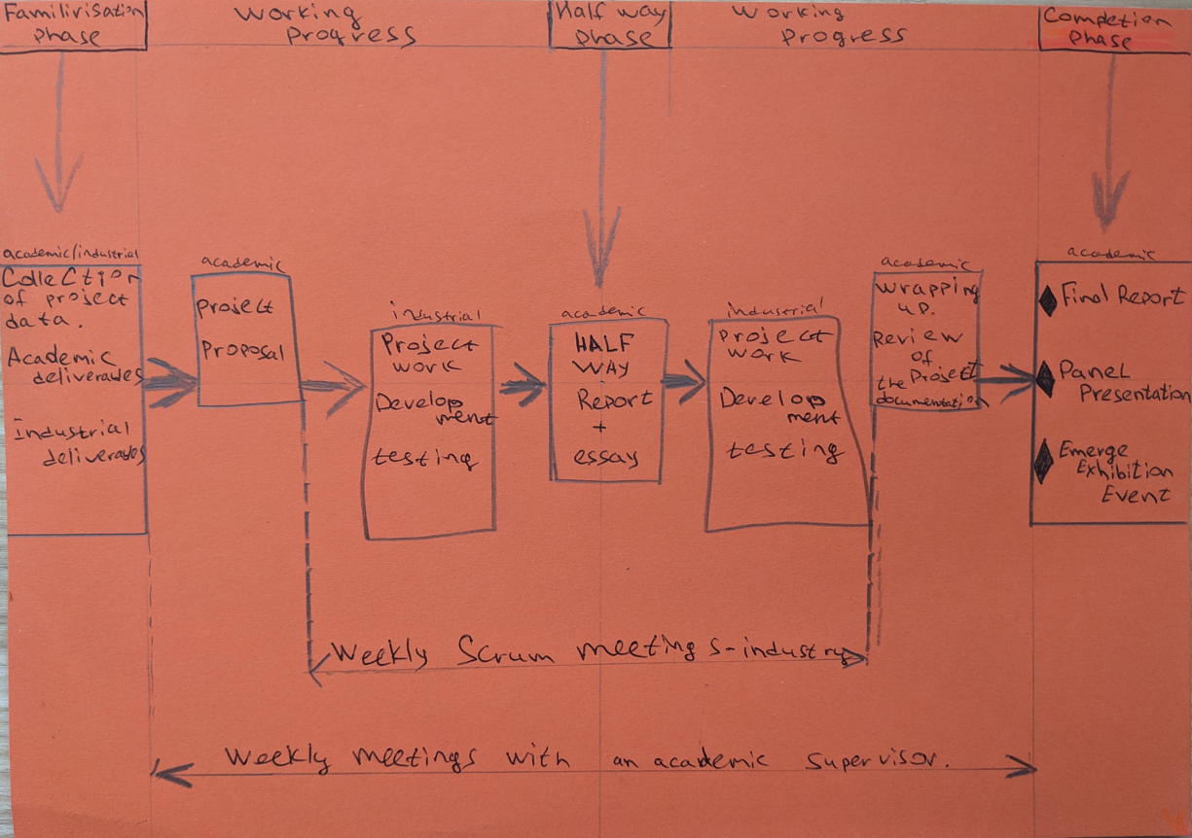

The chosen Agile methodology will be used throughout the entire project for both industrial and academic purposes. Due to their flexibility, all academic deliverables and their components can be reviewed and added or corrected as iterations and the project as a whole progress. It is worth noting that the process is iterative, in which the number of iterations can vary from 1 until the model works properly. Also, the number of deliverables and phases directly depends on the number of iterations, fewer iterations - more deliverables.

## Detailed Project Plan

Below are examples of the timeline, both academic and industrial.

Table

*Detailed Project Plan for Industrial Deliverables*

**

Table

*Detailed Project Plan Academic Deliverables*

**

## Timetable

Below is an example of the time log for academic and industrial purposes.

Table

*Time Management Tool*



## Burndown Charts

Below is the academic burndown chart on 28/August/2023.

### Academic

Figure

*Academic Burndown Chart – Proposal Stage*



A Burndown Chart shows the actual and estimated amount of work to be done in a project. The horizontal y-axis in a Burndown Chart indicates the number of hours remaining, and the vertical x-axis indicates the start of the week. The blue line with crosses (beginning of the week) shows the planned progress of the project.

The green line with squares (beginning of the week) shows the actual situation.

From the chart shown above, it is clear that in the first 5 weeks more time was spent on academic tasks of the project than was originally planned. It is important to ensure that the planned and the actual coincide or try to coincide.

### Industry

Below is the industry burndown chart on 28/August/2023.

Figure

*Industry Burndown Chart Proposal Stage*



The chart above shows that in the third and fourth weeks a little more time was spent than planned, but by February 28 everything had levelled out and was going according to plan.

## Resources/Access Required

Table

*Mapping Resources and Responsible*

|  |  |
| --- | --- |
| **Who is responsible for the supply** | **Resource** |
| Plant Food Research/ student | PC/Laptop |
| Plant Food Research/ student | Proper Internet Connection |
| Student | Smartphone or camera |
| Plant Food Research | Displays/monitors |
| Plant Food Research | Connection HUB |

|  |  |
| --- | --- |
| **Who is responsible for the supply** | **Resource** |
| Student | Visual Studio/ Visual Studio Code |
| Student | Anaconda Python |
| Student | GitHub |
| Plant Food Research/Student | MS Teams – collaboration tool |
| Plant Food Research | SharePoint |

|  |  |
| --- | --- |
| **Who is responsible for the supply** | **Assets** |
| Plant Food Research | Collected information about the amount of yield, crop, and fertiliser calculation. |

## Halfway Report

**Guidelines**

* **include any necessary updates to the project plan and why (phases, timetable, burndown charts, resources)**
* **include burndown charts updated to the halfway point**
* **include evidence of industry work done to the halfway point in the Appendix**
* **include a reflection of aspects of this section – what went well, what didn’t go well, improvements that will be actioned during the remainder of the project**

# Risk Management

Change it

This section will present the main risks that are associated with the project, ways to mitigate and manage these risks to successfully complete the project.

## Approach

The chosen risk management approach is the Risk Management tool by Microsoft Corporation. Risk review is a very important and integral part of any project, so risk reassessment and review will take place on a weekly basis, even though nothing may change in a week.

The table consists of 8 main columns. Below is the information about the contents of these columns:

1. Risk Conditions or in other words the Name of the Risk (what must happen for the risk of an unsuccessful outcome of the project to appear).
2. Risk consequences. Result of the risk, should it happen.
3. Probability. The “likelihood” that the risk will happen is expressed as a percentage. Must be greater than zero but less than 100.
4. Impact. Amount of severity for project if risk is happened. In this case, it is measured on a scale from 1 to 10.
5. Exposure. Calculated automatically by multiplying two columns of Impact and Probability. Used to identify the most serious risk.

The gradation of the impact on the project if the risk happens is as follows.

10 – Catastrophic

7.01-9.9 – High Impact

3.01-7 – Medium impact

1.01-3 – Low impact

0.01-1 – Negligible impact.

1. Mitigation. Includes an action plan to prevent or reduce the risk impact.
2. Contingency. Backup plan in case if a risk becomes reality.
3. Triggers. Represents the reason for using a backup plan.

## Risk Table

Below is the Risk Assessment table.

Table

*Risk Management – Project Proposal Stage*



To keep track of risks, a Log Event table has been created, which will display the risk that occurred. This table will contain information such as:

* Date of risk - when it happened.
* Case - name of the risk.
* Mitigation - measures to prevent or reduce the risk impact.
* Description - brief information about what happened.
* Outcome - what does this mean for the project and the student as a whole.
* Subsequent changes to the table - what changes will be made in the risk table.

Table

*Event Log– Project Proposal Stage*



## Halfway Report

**Guidelines**

* **include any necessary updates to the risk management approach including new risks, risks to remove, updates to risks**
* **include a version of the risk table updated to the halfway point**
* **include a reflection of aspects of this section – what went well, what didn’t go well, improvements that will be actioned during the remainder of the project**

# Quality Assurance

Change it

This section will provide information about the Quality Assurance of the model and project in general, testing and its results will also be presented in this section.

## Approach

To properly track the quality of a product, need a certain system, method. In this project, it was decided to use the Virginia Tech template (Division of Information Technology, 2023). This method will consider:

* Deliverables of the project.
* Stakeholder expectations and standards of quality processes.
* Activity itself. It can be evaluation, code review. In general, measures should be taken to control a certain phase in order to avoid poor product quality.
* Frequency of the process (phase) of the project.
* Who is responsible for the procedure.
* Date the Deliverable was accepted.

## Quality Assurance Table

Below are the Academic Quality Assurance table and Industrial Quality Assurance table.

Table

*Academic Quality Assurance Table*

| **Project Process (Deliverable)** | **Process Quality Standards/ Stakeholder Expectations** | **Quality Assurance Activity** | **Frequency/Interval** | **Who is Responsible** | **Expected Date of Acceptance** | **Actual Date of Acceptance** |
| --- | --- | --- | --- | --- | --- | --- |
| WIL and Confidentiality agreement | Should be signed by people who are involved in a project. | Download WIL agreement and send the document to my industry supervisor. After getting signed, I will submit it to my Academic Supervisor | Once | Sasha Stepanov  PFR Stakeholders  Dr David Weir | 04/08/2023 | In proccess |
| Weekly meeting reports | Evaluation of the previous week's performance score. Submit risk management, burndown chart and quality assurance | All documents must be prepared and submitted before the meeting. | Weekly | Sasha Stepanov  Dr Luofeng Xu | Weekly | Every Monday |
| Project Proposal | Professionally collected set of documents and important information about the project. The document must comply with the standards of professional practice and the issued template. | Academic and Industry Supervisor  feedback.  Follow assessment marking rubric.  Must be unique in regards of plagiarism. | While proposal will not match the quality.  Ideally, once. | Sasha Stepanov  Dr Luofeng Xu  Dr Hamish Brown  Dr David Weir | 24/08/2023 |  |
| Creating a project plan/timeline | The timeline is regularly updated with accurate information | Academic supervisor feedback | Daily/weekly. | Sasha Stepanov | 4/08/2023 | 12/08/2023 |
| Maintaining Burndown chart | Burndown chart which fairly reflects the process. Comments about the process. | Complete the template given by the tutor in a timely manner | Daily/weekly. | Sasha Stepanov | Weekly | Every Sunday |
| Risk analysis and management | Risks are regularly assessed and updated during the project | Submitting the risk management tool for assessment by tutor | Weekly or as needed until the end of the project. | Sasha Stepanov | 5/08/2023  Review - weekly | 5/08/2023  Review – every Sunday |
| Project Proposal checklist | Follows Ara provided proposal checklist | Everything should include from a provided by tutor checklist. | As necessary to completion | Sasha Stepanov | 24/08/2023 | 4/09/2023 |
| Project Proposal Sign off | Follows Ara’s proposal sign-off document. | Ensure that the proposal was created according to the standards and requirements of the project and Ara as a whole. | Once | Dr Hamish Brown  Dr Luofeng Xu  Sasha Stepanov  Dr David Weir | 24/08/2023 | 6/09/2023 |
| Halfway Report | Documentation of progress being made. | Academic and Industry Supervisor  feedback.  Follow assessment marking rubric.  Must be unique in regards of plagiarism. | Once or as necessary to completion. | Sasha Stepanov  Dr Luofeng Xu  Dr David Weir | 29/09/2023 |  |
| Quality Assurance plan | A complete plan in tabular format including all the deliverables, frequency, expectations and who is responsible for quality control. | Creation of a clear plan for assessing the quality based on the template. | Once with a possible review halfway. | Sasha Stepanov  Dr Luofeng Xu  Dr David Weir | 07/08/2023 | 18/08/2023 |
| Methodology Essay | 3,000 words long that covers the topic listed in marking guide | Academic and Industry Supervisor  feedback.  Follow assessment marking rubric.  Must be unique in regards of plagiarism. | As necessary to completion | Sasha Stepanov  Dr Luofeng Xu  Dr David Weir | 27/11/2023 |  |
| Final Report | A full report that meets IT standards. | Consolidation of all documentation into one final report, which would cover the entire project in detail. | Once or as necessary to completion. | Sasha Stepanov  Dr Luofeng Xu  Dr David Weir | 27/11/2023 |  |
| Project Poster | Includes introduction, title, author, methodology, process conclusions, references | Academic and Industry Supervisor feedback and reviews | Once | Sasha Stepanov  Dr David Weir  Dr Luofeng Xu | 27/11/2023 |  |
| Short paper on Poster | Includes introduction, title, author, methodology, process conclusions, references | Academic and Industry Supervisor feedback and reviews | Once | Sasha Stepanov  Dr David Weir  Dr Luofeng Xu | 27/11/2023 |  |
| Short Bio | Professional written of backgrounds and achievements | Academic and Industry Supervisor feedback and reviews | Once | Sasha Stepanov  Dr David Weir | 27/11/2023 |  |
| Panel Presentation | PowerPoint presentation must be submitted. Speech prepared. | Follow assessment marking rubric | Once | Sasha Stepanov | 27/11/2023 |  |

Table

*Industry Quality Assurance Table*

| **Project Process (Deliverable)** | **Process Quality Standards/ Stakeholder Expectations** | **Quality Assurance Activity** | **Frequency/Interval** | **Who is Responsible** | **Expected Date of Acceptance** | **Actual Date of Acceptance** |
| --- | --- | --- | --- | --- | --- | --- |
| Stand- up status update | Template based on scrum. Weekly display of project progress. | Showing my progress, analysing the current situation, listening to feedback. | Weekly | Sasha Stepanov | Every Monday from the start of the project | Every Monday |
| Work Stream (WS2) field configurations complete and in version control | All available data has been prepared and verified for further development. All data in version control. | Validation of available results and their configuration. | Interval is – 40 hours after project was started.  Also a weekly progress check on Scrum. | Sasha Stepanov,  Dr Hamish Brown | 01/10/2023 |  |
| Script to run simulations through API complete and in version control. | Created test cases to check possible cases and check the results for validity. | Creating a python code to successfully simulate sending / receiving data via API. Save to version control. | Upon completion. Also a weekly progress check on Scrum. | Sasha Stepanov,  Dr Hamish Brown | 25/10/2023 |  |
| WS2 Observed data formatted and in version control. | The received date of the correct format and saved in GitHub. | Data cleaning, data validation, saving to version control | Upon completion. Also, a weekly progress check on Scrum. | Sasha Stepanov,  Hamish Brown | 09/10/2023 |  |
| System for visualising model performance complete and in version control | A working simple interface for displaying the results of calculating fertiliser, etc. | Correct and meaningful display of results. Checking if the interface is user friendly for farmers. | After completion of the previous stages or as needed. | Sasha Stepanov,  Dr Hamish Brown | 31/10/2023 |  |
| Integrate testing with Git hub pull request process. | Automatic tests at pull request to Git Hub | Tests created and passed when pulling or requesting from GitHub | After completion of the previous stages or as needed. | Sasha Stepanov,  Dr Hamish Brown | 20/11/2023 |  |

## Test Plan/Scenarios/Cases

Software testing is a method of verifying that the actual software product meets the expected requirements. Involves the execution of predefined algorithms using manual or automated tools to evaluate one or more properties of interest. The purpose of software testing is to identify errors, gaps, or missing requirements specified in the scope.

If there are bugs or defects in the software, they may be detected early in the production of the software and corrected before it is released to production. A properly tested software product provides reliability, security and high performance, which further leads to savings in time, money and customer satisfaction (Logrocorn, 2021).

### Test case/scenario

Below is an example test case. Subsequent tests will be compiled later as the project progresses.

Table

*Test Case for SVS-Model*

**

## Halfway Report

**Guidelines**

* **include any necessary updates to the quality assurance approach**
* **include a quality assurance table updated to the halfway point**
* **include a reflection of aspects of this section – what went well, what didn’t go well, improvements that will be actioned during the remainder of the project**

# 

# Methodology

Change it

This section will describe the main production methodology that was used to carry out the project. Its pros and cons will be described.

## Overview

There is no specific declared methodology for production in PFR, but based on conversations with employees and a mentor, as well as personal experience at rallies, it was concluded that the closest methodology is Agile and Scrum.

The most popular methodology today is **Agile**, because often the production in IT is iterative, which coincides perfectly with the Agile process. Another important criterion for choosing a methodology is constant testing of the prototype, and agile is better suited to this role.

For reporting and evaluating progress to industry, the Scrum methodology will be used, which is an integral part of the Agile framework, this combination is one of the most popular at the moment in the IT field (Peek, 2023).

Due to the difficulty of performing and uselessness of the daily stand-up (for this project), it was decided to exclude the daily stand-ups from Scrum. This choice is also logical, because the team working on a particular project consists of two people.

## Literature Review

**Agile** is a methodology based on continuous improvement through an iterative process and cross-functional collaboration through the participation of several parties, one of which is the client. The main idea of the methodology is the division of large phases or one large phase into smaller phases both in terms of time and volume. Due to this separation, each sub-phase or iteration goes through one cycle, which includes planning, execution, and evaluation (Arun, 2023).

To successfully use Agile, the following steps should be followed (Brush, 2022):

* Project definition: Customer and the team define scope, deliverables, timeframe, goals and requirements.
* Creation of a backlog: The client, the development team and the product owner create a prioritized list of tasks for further execution.
* Sprint planning: The team will have to prepare a sprint that will include the highest-priority tasks from the backlog and how quickly the team can complete it, as well as how much the team can complete in this sprint.
* Sprint execution: The workflow, the execution of tasks in a given period of time. Daily meetings will help to solve the revealed problems.
* Review and demonstration: This step is intended to demonstrate the result of the sprint and get feedback from the customer.
* Retrospect: The team discusses the last sprint in this step and thinks about what went right and what went wrong, how to improve the situation.
* Repeat: The whole process should be put on repeat and the steps should be carried out until the product is delivered to the customer in small portions.
* Continuous improvement. It is important to follow the process and make the necessary adjustments in time in each sprint in order to achieve the best result.

Below is a diagram of the classic use of Agile for production. It can be seen from the diagram that each iteration or sprint begins with planning, then comes design, development, testing, deployment, each sprint ends with a review of the past sprint. This cycle will continue until the product meets the customer's requirements.

Figure

*Diagram of Agile Methodology Process*

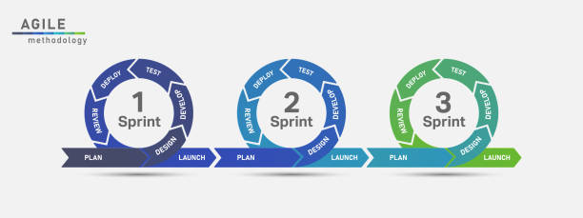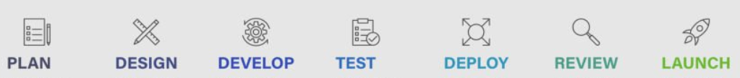

*Note:* AdaptedFrom *iStock (*[*https://www.istockphoto.com/vector/agile-development-process-infographic-gm1264320878-370268788?phrase=agile+process+diagram*](https://www.istockphoto.com/vector/agile-development-process-infographic-gm1264320878-370268788?phrase=agile+process+diagram)*).* Upload date: August 06, 2020. Copyright: Ztaro.

**Scrum** was created to make methodologies like Waterfall more successful by adding flexibility to the methodology. This framework is designed to facilitate project management, team member collaboration, and to help teams naturally adapt to changing conditions and user requirements (Malsam, 2023).

Scrum consists of such components as artifacts. Artifacts are :

* Product backlog: The volume of work, structured by importance, is performed by the product owner and looks like a list.
* Sprint backlog: a plan for the next tasks that developers have to complete. It can also be identified as a set of user stories for one single sprint. Sprint is a predetermined period of time in which a pre-selected amount of work from the backlog must be completed.
* Product increment: This includes all the work done or all the tasks done. This artifact can be described as the summation of everything done (Chandana, 2023).

Below is an example of a classic Scrum Sprint with all possible components.

Figure

*Diagram of Scrum Framework Process*

*Note*: From *Techtarget (*<https://www.techtarget.com/searchsoftwarequality/definition/Scrum> *)* By Ben Lutkevich, Technical Features Writer.

As for those responsible for the sprints and all its components, as a rule, the composition of the sprint team is as follows.

* **Product owner**. The position speaks for itself, as a rule it is a stakeholder who is not part of the company. Can be names as at the link between clients and developers.
* **Scrum Master**. As a rule, a person from the same company as the developers, but there may be outsourcing. The primary responsibility of the Scrum Master is to ensure Scrum best practices are followed. Good leadership and human skills are a must have for this position.
* **Development team**. All those who will be responsible for the implementation of the tasks at a certain time - the workforce. In some cases, the Scrum Master is also part of the development team (Lutkevich, 2021).

Below is a diagram of a Scrum Team.

Figure

*Diagram of Scrum Team*

*Note*: From *Techtarget (*<https://www.techtarget.com/searchsoftwarequality/definition/Scrum> *)* By Ben Lutkevich, Technical Features Writer.

## Critique (Pros and Cons)

This subsection will present the advantages and disadvantages of the chosen methodology. It is important to be aware of such nuances before using the methodology. Only aspects of Agile methodology will be considered here, as it is the basis for the process.

|  |  |
| --- | --- |
| **Advantages** | **Disadvantages** |
| * Popular methodology (Sufficiency of information) * Collaboration * Flexibility * Improved performance and product quality. * Customer oriented * Acceptance of uncertainty * Immediate Feedback (Qualium Systems, 2017). | * Lack of Documentation * Possible scope creep * It takes a lot of time to prepare. * Lack of Prediction * Customer oriented (might be a disadvantage too) * The need for experience * Human factor – It can be hard for people to follow the rules. |

For better visualization of project tasks, and the distribution of tasks by time and significance, for simplicity, it was decided to use **Kanban** (Shore Labs, n.d.), as well as a paper journal to describe the process, tasks, work done, feelings, fears, and just notes.

Figure

*Example of Creating a Task in Kanban Board*

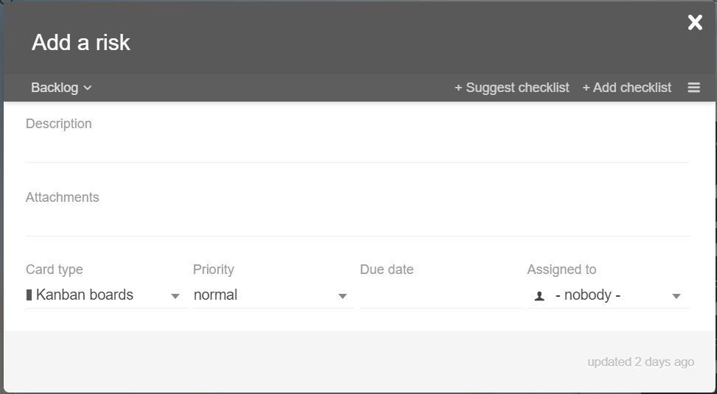

Figure

*Example of Kanban Board*

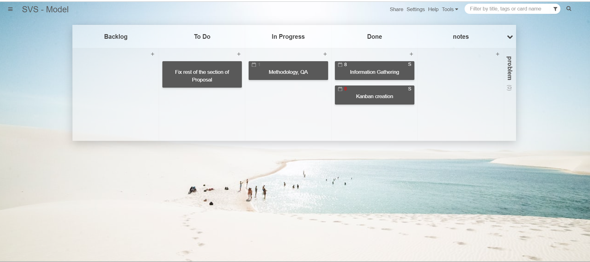

**In conclusion**

This project will use a modernised version of Agile, which will be carried out through the Scrum framework, since Scrum is a subset of Agile (Cprime, n.d.). The chosen methodology and framework fit perfectly together and will help in achieving the goal, namely the successful completion of the project. It is worth noting that the chosen methodologies add flexibility to the project, iterations can be added and changed. Also, the process of using and the framework itself can change and adapt along the course of the project. For example, due to the limited size of the team (two people), the industrial supervisor will act as the owner of the product and the sprint master. This is due to the fact that the customer or the real owner of the product is the State, since the entire project is sponsored by them. But to simplify the situation, the supervisor will be the owner of the product.

Another example of how the methodology may change in the future as the project progresses is the elimination of an Agile weakness such as missing or insufficient documentation. Documenting the progress and the entire process as a whole is an indispensable and important part of the project, so it will be given special attention.

## Halfway Report

This section will contain all the necessary information regarding updates to the methodology used in the project at the time of writing the halfway report. And also, an analysis of what went well, what didn’t go well, improvements that will be actioned during the remainder of the project.

During the first half of the project, a kanban board was used daily. This turned out to be a very convenient tool for visualizing and managing work as it moves through a process in this project.

Kanban was used for both the academic part and the industrial part. In academic work, it was used to break large tasks into smaller ones, which could later be broken into even smaller ones. This helped get rid of procrastination and focus on the process and progress. Quite common personal problems of postponing work on writing reports and project proposals are fear of the amount of work, not knowing where to start, as well as an excessive amount of task. This is where the student helped me. Another important advantage of using Kanban is the visible result in the form of completed tasks. This gives additional motivation and creates the feeling that work has been done, even if sometimes a small one.

Below is an example of using a Kanban board for academic purposes.

Figure

*Usage of Kanban Board – Halfway Report Stage*

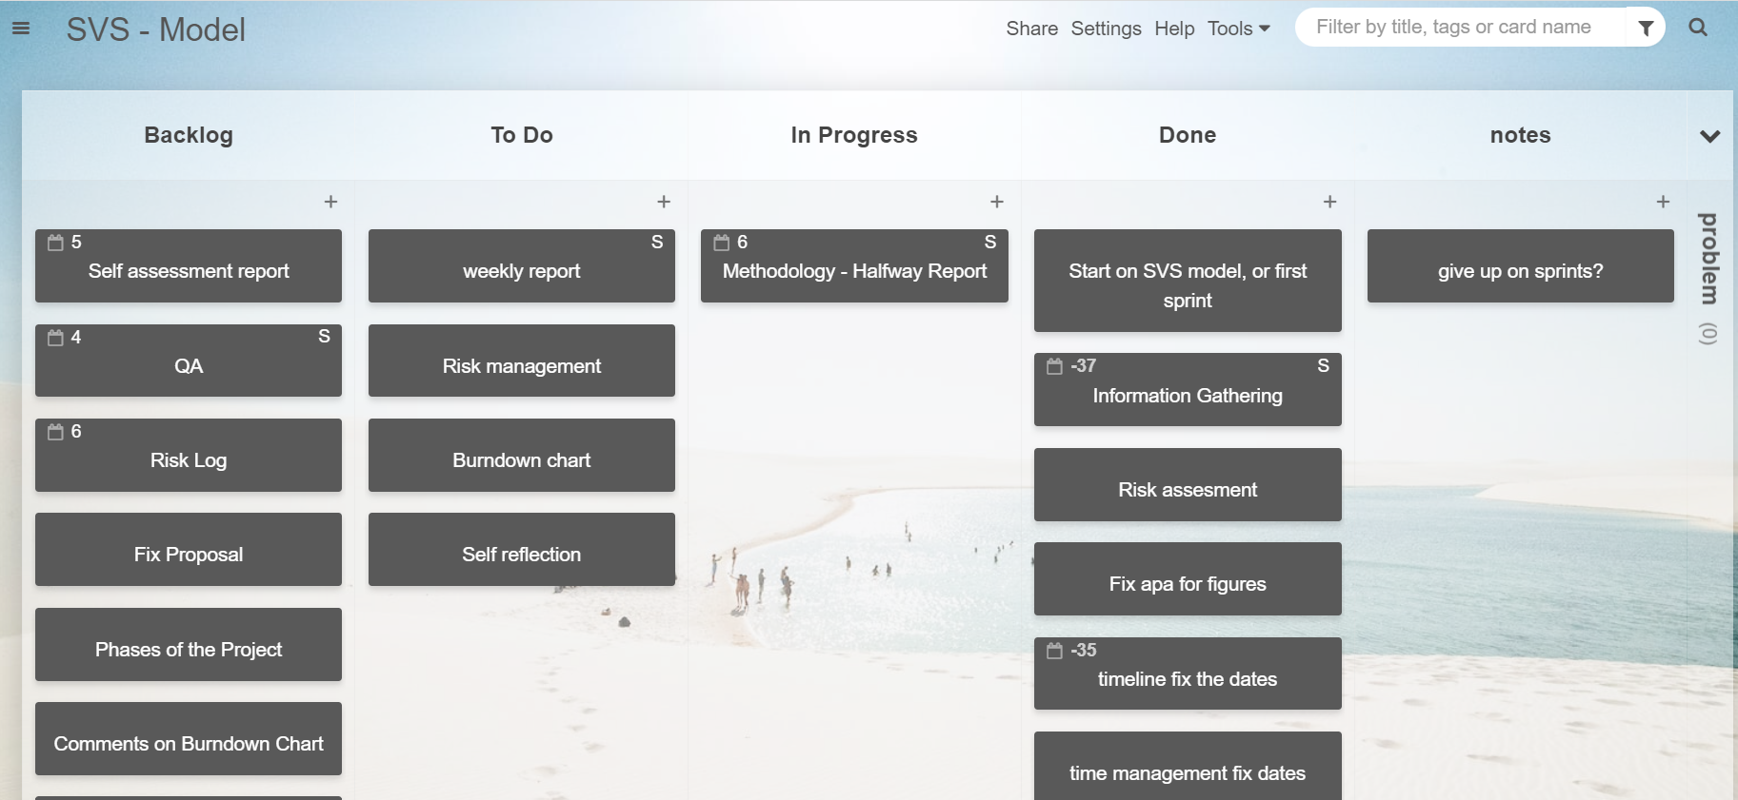

Kanban is also convenient because you can set a due date, which will be indicated on the task in the form of the remaining days until the deadline. It is also possible to indicate to whom this task was assigned; in this project this feature is rudimentary since the kanban was used by one person.

This Kanban board is a limited free version, since you can only create two boards, but it is ideal for this project.

Kanban is used daily, but not all of its features are used or used to their fullest, specifically priority and due date. Instead of giving priority to tasks in digital terms, the student moved tasks from the Backlog to the To Do column, which was an indicator of the high priority of the task for the student. The due date is a very useful feature, and, in the future, it is worth using it much more often in order to have a structured approach to completing project tasks.

# Professionalism

This section will describe generally accepted industry standards and rules for working in the company. In addition, the legal part of the project will be described.

## Professional Standards

This section will cover professional standards (Institute of IT Professionals, 2015) and how they will be applied by the student.

### Reliability and Accountability

Reliability and Accountability are indispensable attributes of working professionalism. It is important to show up on time, be organized and ready to meet all the necessary deadlines. Every student is strongly encouraged to listen to instructions, follows directions, and accepts and acts on constructive criticism.

### Communication

Each student should be polite and intelligent when talking to others. It is important to clearly and correctly formulate questions, problems, tasks. It is important not to cross the set boundaries and be a professional.

### Attitude

Each student must be a professional in his field, not only at the level of ICT Specific Skills, but also in behaviour with others. It is important not to bring your personal problems to work so that it does not negatively affect the process. Inappropriate behaviour can also leave a bad impression on Ara Te Pukenga. The ability to be friendly, have a positive outlook and shows respect when dealing with peers, supervisors, industry and clients/contacts are indispensable components of a successful workflow.

### Teamwork

Each student should be a full-fledged team member who will be useful for the common good. This includes details such as:

* Do not hesitate to ask for help.
* To provide assistance to those in need in a timely manner, here it is worth clarifying that help is needed when asked, and not imposed.
* Perform the assigned share of the work, without throwing off duties on others.

### Motivation

Student commits to be motivated, to take the initiative, because the lack of motivation leads to poor performance, which can lead to bad consequences, such as expulsion from the project.

### Open to Learning

It is important to be interested and proactive in learning new skills, as this is a great opportunity to gain experience. Initiative and problem-solving attitude will be welcome. The student plans to receive new information from various sources, such as YouTube, Udemy, and other students.

## Relevance of ITP Code of Ethics

In order for the project to be legal and ethically correct, so that there are no legal problems in the future, certain dogmas and laws should be followed. These tenets will be presented below (ITP New Zealand Code of Ethics , 2017).

### Good Faith

Student shall treat people with dignity, good faith, and equality; without discrimination; and have consideration for the values and cultural sensitivities of all groups within the community affected by work.

### Integrity

This Principle is relevant to this project. Student shall act in the execution of profession with integrity, dignity, and honour to merit the trust of the community and the profession, and apply honesty, skill, judgement, and initiative to contribute positively to the well-being of society.

### Community Focus

This Principle is relevant to this project. Responsibility for the welfare and rights of the community shall come before my responsibility to my profession, sectional, or private interests or to other professionals.

For example, the project is called SVS- Sustainable Vegetable System and is aimed at the common good of both the country and the environment. The project also has an educational part, as farmers need to be explained and proved that the amount of fertiliser they use can be reduced, which will lead to less environmental damage and save them money.

### Skills

This Principle is relevant to this project. As a student I shall apply my skills and knowledge in the interests of the project’s client or employers for whom I will act without compromising any other of these Tenets.

For example, as a student of the third year, the owner of this proposal uses all possible resources and previously acquired skills to obtain the best result for the client.

### Continuous Development

This Principle is relevant to this project. I shall develop knowledge, skills, and expertise continuously through the project.

For example, a project implies an iterative process in which there will be testing which in turn includes work on bugs and continuous improvement of not only the product, but also skills.

### Informed Consent

This Principle is relevant to this project. I shall take reasonable steps to inform myself or my industry supervisor of the economic, social, environmental, or legal consequences which may arise from my actions.

The student signed a non-disclosure declaration as the project involves working with sensitive data.

### Conflicts of Interest

As a student I shall inform my industry supervisor of any interest which may be, or may be perceived as being, in conflict with the interests of my mentor, or which may affect the quality of service or impartial judgement, if such ever arise during the duration of the project.

### Competence

Student shall follow recognised professional practice and provide services and advice carefully and diligently only within my areas of competence, which is in the case of this project is solely software/web development, database, and testing.

## Relevant Legislation

This section includes the laws and regulations that must be taken into account when working on a project. These laws and regulations may be applicable both to this project and to a specific situation.

### Privacy/Confidentiality

All collected information from farmers or potential users will be used only for the purposes of a specific project and only with permission. All date provided by farmers in the future will be by agreement and will contain metadata such as “crop yield”, “crop name”, “name of previous crops” and “amount of fertiliser” used. As a rule, this data is in the public domain and is not confidential. No personal data that could identify a specific person will be collected.

While it is not planned to use personal data, best practice is to be safe and follow the New Zealand Privacy Act 2020.

**Privacy Act**

The Privacy Act 2020 (Office of the Privacy Commissioner 2020) sets out rules regarding how user information is collected, stored, distributed or viewed. It guarantees that:

If you want - you can get an access to your information.

You must be notified if and when your information is collected.

All information that has been collected is used in shared in an appropriate way.

All information is secure and safe.

There are twelve main principles that create a whole act about privacy.

1. Principle is about reason for collection.
2. Principle is staying that information that collected must be from a source.
3. Principle saying that organization should be open for the reason of gathering information.
4. Principle is about way of collecting information.
5. Principle is about security and the way is information is going to be stored.
6. Principle is about person’s right to access his own information.
7. Principle staying that person is allowed to correct it in a right way.
8. Principle staying that organization must check for correctness of information they are collecting.
9. Principle staying that all information that has been gathered should have an expiration day.
10. Principle says that there are limits of the ways collected information can be used.
11. Principle states that the information collected may only be used for the purposes for which it was originally collected.
12. Principle states that the information collected may only be used for the purposes for which it was originally collected and do not leave New Zealand.
13. Principle states that organizations cannot assign an ID to a customer, unless specified.

Following these principles will help avoid any legal issues (Office of the Privacy Commissioner, 2020).

### Copyright

This legislation is not relevant to this project, since it is not planned to use someone else's creation, the entire model was created from scratch.

### Patents

Upon completion of the entire SVS project, the model will be patented in accordance with all standards. Since this is a research centre, the organization has a legal department that deals with patents and legislation in general.

# Sustainability, Inclusive Practice and Te Tiriti o Waitangi

This section will describe the measures taken to preserve the environment and cultural values. Particular attention should be paid to sustainability, respect for the environment and New Zealand's Māori national culture.

## Relevance of Principles to Student and Industry

Understanding and following the core principles of Te Tiriti o Waitangi (Ministry of Business, Innovation & Employment, n.d.) is an important part of this project. These principles are:

* Kaitiakitanga - means guardianship, protection, preservation or sheltering. It is a way of managing the environment, based on the traditional Māori world view (Royal, 2007).
* Rangatiratanga - in the cultural sphere relates to stewardship of others, advocating for others and the community, doing the right thing for their people and ensuring wellbeing and generosity of spirit (The Independent Māori Statutory Board, n.d.).
* Whanaungatanga - (noun) relationship, kinship, sense of family connection - a relationship through shared experiences and working together which provides people with a sense of belonging. It develops as a result of kinship rights and obligations, which also serve to strengthen each member of the kin group (John C Moorfield, n.d.).
* Mana Reo - means developing communication skills. Mana Reo is literally the mana of language. This means the power or authority of language and communication (Smith, 2017).

### Kaitiakitanga

This project is aimed directly at improving the situation with the environment both in the country and at the international level. The essence of the project is to reduce the use of fertilisers where possible, in order to reduce the release of excess nitrogen into the soil and water bodies.

Other aspects will also be carried out to save the world around us, such as:

* Work from home to avoid wasting fuel and polluting the environment.
* The personal computer will be used, which will remove the burden of acquiring a new computer from the industry.

### Rangatiratanga

During the project agreement, it was established that the student will make decisions himself and gain new experience in this. Also, the client will act in his own interests, but everything remains within the framework of the project.

There will be no pressure on the part of the student on industry employees, students or teachers.

### Whanaungatanga

Although the project takes 300 working hours, students are encouraged to establish friendly relations with all project stakeholders, both for socialisation purposes and for future cooperation. For example, despite the outcome of this project, the owner of the project will see and maintain friendly relations with the mentor, since both are engaged in judo in the same club.

The student must not cross the boundaries of what is permitted in dealing with both the industry and the academic part. This is considered both a professional part and a social part.

### Mana Reo

It is highly recommended to use the Māori language as required by the project, such as greetings and farewells. This is done to maintain the Māori culture in New Zealand.

## Halfway Report

This section will describe the progress of pursuing **Sustainability, Inclusive Practice and Te Tiriti o Waitangi** after working half an hour in the industry -150 hours.

### Kaitiakitanga

This project by its nature is aimed at improving the environment. Even the name of the project is “Sustainable Vegetable System – SVS Model”.

Also, to improve the environment, or not make it worse, the following, albeit small, but still measures are taken:

* Using reusable utensils during meals, especially for hot drinks, which are so often consumed in organizations.
* Using a personal laptop.

Despite this, it is worth mentioning that there is one negative impact on the environment that the student really regrets but cannot do anything about at the moment. It is important for a student to be personally present at the workplace, which leads to the use of a car on a daily basis, which has an adverse effect on the environment.

### Rangatiratanga

The implementation of the project follows this principle, both academically and industrially. In industry, a student gains interesting experience in decision-making, albeit under the strict guidance of a supervisor. No pressure was noticed from the supervisor, all decisions were made in a positive professional atmosphere.

As for the academic part, the student is provided with great assistance in completing the academic part of the project; a lot of useful feedback was received, which was aimed at improving the project proposal. This feedback was professional and constructive, was taken into account and almost all aspects were implemented or discussed with the supervisor. The student is also provided with moral support, which is important for the successful completion of this project.

### Whanaungatanga

This principle is followed throughout the project. With the help of an industrial supervisor, almost every day the student meets someone new from the company, which leads to the expansion of the student’s social circle.

Communication, both live and in the form of correspondence, takes place in a friendly but at the same time professional manner.

As for academics, the boundaries in communication were not crossed and everything took place in a friendly, albeit professional, manner.

### Mana Reo

This principle is supported in Plant and Food Research and specifically in the implementation of this project. Below are examples of the use of the Māori language:

* Very often, greetings are conducted in Māori, as are farewells.
* Announcements about events and simply booklets on stand newspapers are presented in Māori and duplicated in English.
* The student was brought into the game to learn the Māori language – Tākaro (Game Kings, 2019). The game was quite interesting and educational, despite the fact that it was very simple. The idea is to match pictures and then find the name of the image in Māori. This helps to remember the meaning of Māori words, as the game is very rehearsal.

In conclusion, it is worth noting that the student is satisfied with the implementation of the principles of this section both at the industrial and academic levels. In the future, it is planned to continue to follow and meet these principles.

# Self-Assessments

This section will contain information about self-assessment at both the academic and industrial levels.

Who is doing it ???

## Halfway Self-Assessment

### Industry

**Guideline – include of copy of your industry self-assessment using the halfway rubric**

### Academic

**Guideline – include of copy of your academic self-assessment using the halfway rubric**

# Reflections

This section will describe my opinion on the project, its successes and failures. Will be discussed what could have been done better and what worked out very well. In order to keep some kind of record of the experience gained and my attitude towards the project, a special approach recommended by the Asana website will be used.

Throughout the project, a journal will be used, where notes will be made about what is happening in the project. Notes will concern not only the practical part (coding, analysis, database), but also the social part, namely the use of soft skills in a large company.

## Approach

This approach consists of 5 steps:

* Identify. To accomplish this step three questions, need to be answered: What went wrong? What went right? What can be improved?
* Document. Report it in some form of documentation: summary, notes, recommendations.
* Analyse. Analysis and drawing conclusions. It can take place both in the middle of the project, and at the very end, so to make sure not to make the same mistakes in the future.
* Store. Analysis and drawing conclusions. It can take place both in the middle of the project, and at the very end, so as not to make the same mistakes in the future.
* Retrieve. In the event of a foreseen repeated error or difficulty, it is necessary to retrieve the documentation to mitigate this error (Martins, 2022).

## Halfway Report

This section contains a personal reflection on the work done during the first half of the project.

As mentioned above, a journal was used for personal reflection, where daily notes were made about the process, new skills, success and mistakes when working on the project.

Below is the Reflection Log table, which will display the performed approach.

Table

*Reflection Log Table – Halfway Stage*

|  |  |  |  |  |  |
| --- | --- | --- | --- | --- | --- |
| **Case** | **Wrong, right or can be improved** | **Form of documentation** | **Analysis of the case, outcome** | **what lesson have been learned** | **Has been retrieved(in case of repetition)?** |
| Not following the naming convention. | Went wrong | Physical Journal | When creating the prototype, the names of classes, variables, etc. were too generic and did not reveal their full meaning. This was due to the fact that the student thought that he was working with a prototype that would not be used in the model in the future. It was decided to use this prototype, which led to further difficulties in some parts of the code. | Follow the rules of the naming convention from the very beginning. | No |
| An unstructured approach to information retrieval. | Went wrong | Physical Journal | The task was set to find a solution to the existing problem. Due to the fact that the student did not create a minimum search structure and did not identify key points, a lot of time was wasted. The student could not concentrate on one thing and constantly changed resources to find a new solution to the problem. The consequence of this was a waste of time without a solution found. | It is important to draw up at least a minimum search plan and structure, as well as a clear idea of the goal. | No |
| Failure to check product control version. | Went wrong | Physical Journal | The version control was not checked in a timely manner and the student worked on an old version of the model, which led to some inconsistencies in the code, however, the problem was quickly found. | Checks for new versions are carried out every morning. | No |
| Failure to timely save to version control. | Went wrong | Physical Journal | The prototype was not saved into version control on time, then careless manipulations with the prototype led to its malfunction. Time was wasted returning to the starting point. Timely saving to version control would help save valuable time. | The student tries to maintain version control of each working prototype. | Yes |
| Keeping a physical journal. | Went right | None | It was a good idea to keep a physical journal. Besides convenience, it's nice to write something by hand instead of typing it for a change. | The physics journal will continue to be maintained until the end of the project. | Yes |
| Asking all possible resources for help in a timely manner. | Went right | None | The request for help came from the student in a timely manner. At first, the student tried to solve the existing problem himself; after the allotted time had expired, the student turned to the help of an industrial supervisor, an academic supervisor, colleagues at work, and students. | The same practice will continue. | Yes |

# References

Arun, R. (2023, June 14). *What is Agile: Understanding Agile Methodology and Principles*. Retrieved from Simplilearn - Online Certification Training Course Provider: https://www.simplilearn.com/tutorials/agile-scrum-tutorial/what-is-agile

Brush, K. (2022, November). *Agile software development*. Retrieved from techtarget: https://www.techtarget.com/searchsoftwarequality/definition/agile-software-development

Chandana. (2023, 07 24). *Scrum Project Management: Advantages and Disadvantages*. Retrieved from Simplilearn: https://www.simplilearn.com/scrum-project-management-article

Cprime. (n.d.). *What is Agile? What is Scrum?* Retrieved from Cprime: https://www.cprime.com/resources/what-is-agile-what-is-scrum/

Division of Information Technology. (2023). *Project Quality Assurance*. Retrieved from Virginia Tech: https://it.vt.edu/projects/project_management/qualityassurance.html

Eby, K. (2022, February 23). *How to Successfully Plan an IT Project*. Retrieved from Smartsheet: https://www.smartsheet.com/content/it-project-plan

Institute of IT Professionals. (2015, June). *Institute of IT Professionals.* Retrieved from ITP: https://itp.nz/files/IITP%20Code%20of%20Practice.pdf

ITP New Zealand Code of Ethics . (2017, May). *IT Professionals.* Retrieved from ITP: https://itp.nz/upload/files/ITP%20Code%20of%20Ethics.pdf

John C Moorfield. (n.d.). *whanaungatanga*. Retrieved from Te Aka Maori Dictionary: https://maoridictionary.co.nz/word/10068

Logrocorn. (2021, January 12). *What is software testing? Definition, bases and types.* Retrieved from Logrocorn: https://logrocon.ru/news/testing_is

Lutkevich, B. (2021, October). *Scrum*. Retrieved from Techtarget: https://www.techtarget.com/searchsoftwarequality/definition/Scrum

Malsam, W. (2023, July 11). *Scrum Methodology: An Introduction to the Scrum Process*. Retrieved from ProjectManager: https://www.projectmanager.com/blog/scrum-methodology

Martins, J. (2022, 11 6). *How to capture lessons learned in project management*. Retrieved from Asana: https://asana.com/resources/lessons-learned

Ministry of Business, Innovation & Employment. (n.d.). *Principles from te ao Māori the Māori worldview | He aronga Māori ki ngā mātāpono*. Retrieved from Ministry of Business, Innovation & Employment: https://www.mbie.govt.nz/business-and-employment/economic-development/just-transition/just-transitions-guide/foundations/principles-from-te-ao-maori-the-maori-worldview/#:~:text=Te%20ao%20M%C4%81ori%20emphasises%20the,and%20lore%20and%20m%C4%81tauranga%20

Office of the Privacy Commissioner. (2020). *Privacy Act 2020 and the Privacy Principles*. Retrieved from Privacy Commissioner: https://privacy.org.nz/privacy-act-2020/privacy-principles/

Peek, S. (2023, April 28). *What Is Agile Scrum Methodology?* Retrieved from businessnewsdaily: https://www.businessnewsdaily.com/4987-what-is-agile-scrum-methodology.html

Plant and Food Research. (2010, April 20). *Merger Creates New Research Institute*. Retrieved from Plant and Food Research: https://www.plantandfood.com/en-nz/article/merger-creates-new-research-institute

Qualium Systems. (2017, 12 21). *The Pros and Cons of Agile Methodologies*. Retrieved from Qualium-systems: https://www.qualium-systems.com/blog/business/the-pros-and-cons-of-agile-methodologies/

Royal, T. A. (2007, September 24). *Story: Kaitiakitanga – guardianship and conservation*. Retrieved from teara: https://teara.govt.nz/en/kaitiakitanga-guardianship-and-conservation

Shore Labs. (n.d.). *Increase team performance with*. Retrieved from Kanban Tool logo: https://kanbantool.com/ru/

Simplelearn (Director). (2021). *Design Thinking And Agile* [Motion Picture].

Smith, G. (2017, March 10). *What Is Mana Reo? Discover 2 Great Ways To Describe Learner Centred Teaching*. Retrieved from thisisgraeme: https://thisisgraeme.me/2017/03/10/concepts-what-is-mana-reo/

The Independent Māori Statutory Board. (n.d.). *Rangatiratanga*. Retrieved from Independent Maori Statutory Board: https://www.imsb.maori.nz/maori-wellbeing-in-tamaki-makaurau/rangatiratanga/

Ztaro. (n.d.). *Agile development process infographic stock illustration*. Retrieved from istockphoto: https://www.istockphoto.com/photos/agile-process-diagram

# Appendices

This section contains all additional and complete information regarding the project and its specification.

Appendix A – Evidence of Industry Work - Halfway Report Phase